5th March 2017 • united against human trafficking
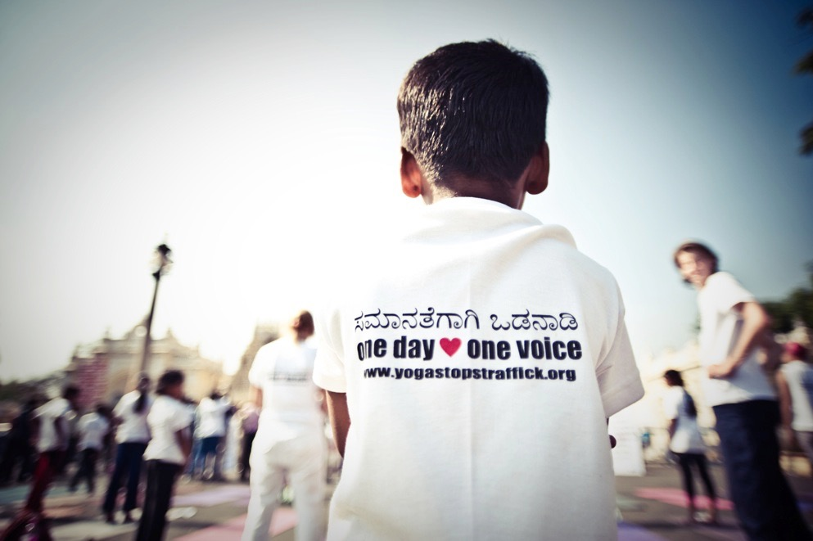
Make a difference. All you need is your yoga mat.

On the same day thousands of yoga practitioners will show their solidarity by taking part in similar events across the globe – from London to New York, Sao Paulo to Bangkok.

These events will raise awareness and generate funds for Odanadi: to support their work rescuing and rehabilitating victims of human trafficking, exploitation and abuse, and educating and empowering vulnerable communities.

